–––The "**Key Partners**" section of a business model canvas is used to identify the key external partners that a business relies on to create and deliver its value proposition.

1.Restaurants: These partners are likely suppliers of the food that our business delivers to customers.

2.Delivery Partners: These partners are likely responsible for physically delivering the food to customers.

3.Investors: These partners provide the financial resources needed to support our business operations.

4.Developers: These partners are likely responsible for creating or maintaining any software or technology used by our business.

5.Payment sites: These partners provide the payment processing services that enable our business to accept payments from customers.

The "**Key Activities**" section of a business model canvas is used to identify the key activities that a business must perform in order to create and deliver its value proposition.

1.Provide search services for searching the right restaurants and food items: This activity allows customers to easily find and select the food they want to order.

2.Managing logistics to process orders: This activity involves coordinating with the delivery partners and restaurants to ensure that orders are prepared and delivered to customers in a timely manner.

3.Collecting restaurant information: This activity involves gathering information such as menus, opening and closing times, ratings, and reviews from restaurants to provide customers with a complete picture of what each restaurant offers.

4.Creating and managing technology infrastructure: This activity involves the development and maintenance of the technology infrastructure that supports the business, such as the website or mobile app.

The "**Key Partners**" section of a business model canvas is used to identify the key external partners that a business relies on to create and deliver its value proposition.

1.Restaurants: These partners are likely suppliers of the food that our business delivers to customers.

2.Delivery Partners: These partners are likely responsible for physically delivering the food to customers.

3.Investors: These partners provide the financial resources needed to support our business operations.

4.Developers: These partners are likely responsible for creating or maintaining any software or technology used by our business.

5.Payment sites: These partners provide the payment processing services that enable our business to accept payments from customers.

The "**Customer Relationships**" section of a business model canvas is used to identify the types of relationships a business has with its customers, and how it maintains and enhances those relationships.

1.Up-to-date ratings and reviews: By providing customers with access to current ratings and reviews of restaurants, our business helps them to make informed decisions about where to order food from.

2.Customer engagement activities: our business engages with customers through various activities such as promotions, contests, etc.

3.communication channel and customer support: our business provides customers with multiple ways to communicate and get support, such as phone, email, or live chat.

4.Social media pages: our business uses social media platforms to interact with customers, promote its services, and gather feedback.

The "**Customer Segments**" section of a business model canvas is used to identify the specific groups of customers that a business targets.

1.Users who look for restaurants of various cuisines: These customers are interested in finding and ordering food from a wide variety of restaurants, regardless of the type of cuisine they offer.

2.Users who prefer home delivery: These customers are interested in ordering food for delivery to their homes rather than dining in at a restaurant.

3.Restaurants who want to advertise their services: These customers are interested in using our platform to promote their services and reach a wider audience of potential customers.

4.Restaurants who do not offer delivery services: These customers are interested in using our platform to offer delivery services to their customers without having to invest in their own delivery infrastructure.

The "**Key Resources**" section of a business model canvas is used to identify the resources that a business needs to operate and deliver its value proposition.

1.Large database of restaurants: our business needs a comprehensive and up-to-date database of restaurants in order to provide customers with a wide range of options to choose from.

2.Large database of users: our business needs a large and active user base in order to generate revenue through commissions on orders and advertising.

3.Large database of delivery agents: our business needs a large pool of delivery personnel to ensure timely and efficient delivery of food to customers.

4.Technology platform: our business needs a robust and user-friendly technology platform to enable customers to search and order food, and to connect with restaurants and delivery agents.

The "**Channels**" section of a business model canvas is used to identify the channels through which a business reaches and communicates with its customers.

1.IOS mobile application: our business provides a mobile application for customers using Apple devices, such as iPhones and iPads, to search for and order food.

2.Android mobile application: our business provides a mobile application for customers using Android devices, such as smartphones and tablets, to search for and order food.

3.Website: our business provides a website that customers can use to search for and order food, as well as to access information about the business and its services.

The "**Cost Structure**" section of a business model canvas is used to identify the costs associated with operating a business, and how they relate to revenue.

1.Large database of restaurants: Maintaining a comprehensive and up-to-date database of restaurants requires ongoing research and data entry, which can be costly. Additionally, the cost of storage and management of the database also needs to be considered.

2.Large database of users: Building and maintaining a large user base requires ongoing marketing and customer acquisition efforts, which can be costly.

3.Large database of delivery agents: Recruiting and maintaining a large pool of delivery personnel requires ongoing efforts, which can be costly.

The "**Revenue Streams**" section of a business model canvas is used to identify the ways in which a business generates revenue.

1.Advertising: Our business generates revenue by selling advertising space on its mobile applications and website to restaurants and other businesses.

2.Online ordering: Our business generates revenue by charging a commission on all food orders placed through its platform.

3.Data: Our business generates revenue by selling data on customer behavior, preferences, and demographics to restaurants and other businesses.

4.Consulting: Our business generates revenue by providing consulting services to restaurants and other businesses on how to improve their online presence and reach more customers.

- Users who look for restaurants of various cuisine

- Users who prefer home delivery

- Restaurants who want to advertise their services

- Restaurants that do not offer delivery services

**Key Partners**

**Customer Segments**

**Customer Relationships**

- Restaurants

- Delivery Partners

- Investors

- Developers

- Payment Sites

- Provide search services for searching the right restaurants and food items.

- Managing logistics to process orders

- Collecting restaurant information (menu card, opening and closing time, rating, review and much more)

- Creating and managing technology infrastructure.

- One stop app for food lovers

- Allow restaurants to stand out

- Bridge the gap between customer and restaurants with application

- Provide ratings and reviews to evaluate restaurants

- Provide additional source of income to delivery guy

- Online food ordering

- Up to Date Ratings and Review

- Customer Engagement Activities

- Active Communication Channel and Customer Support

- Social media pages

**Key Resources**

**Channels**

**Value Propositions**

**Key Activities**

**Cost Structure**

**Revenue Streams**

- IOS mobile application

- Android Mobile Application

- Website

- Large database of restaurants.

- Large database of users.

- Large database of delivery agents.

- Technology platform

- Advertising

-Online Ordering

-Data

-Consulting

-Large database of restaurants.

-Large database of users.

-Large database of delivery agents.

-Technology platform

**USER PERSONA**

*Note- Please find below drive link for clear images of User Persona & User Journey.*

Drive link : <https://drive.google.com/drive/folders/1sJeWvgsLWvsAS_x7KM_VsehisAiK47Km?usp=share_link>

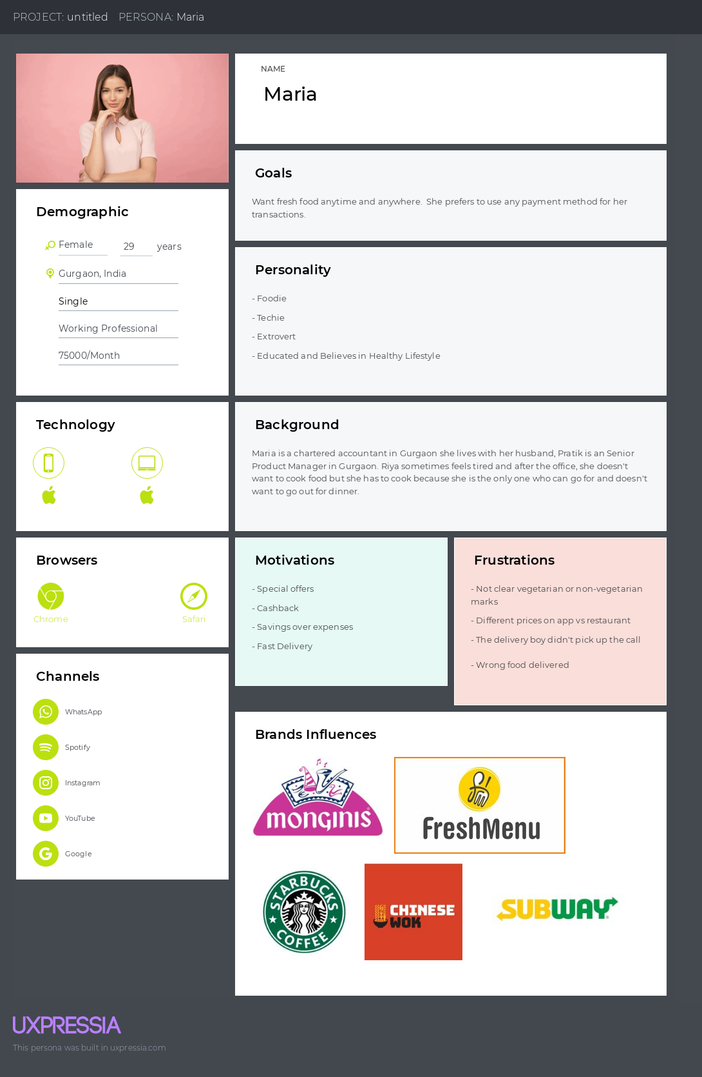

**USER JOURNEY MAP**

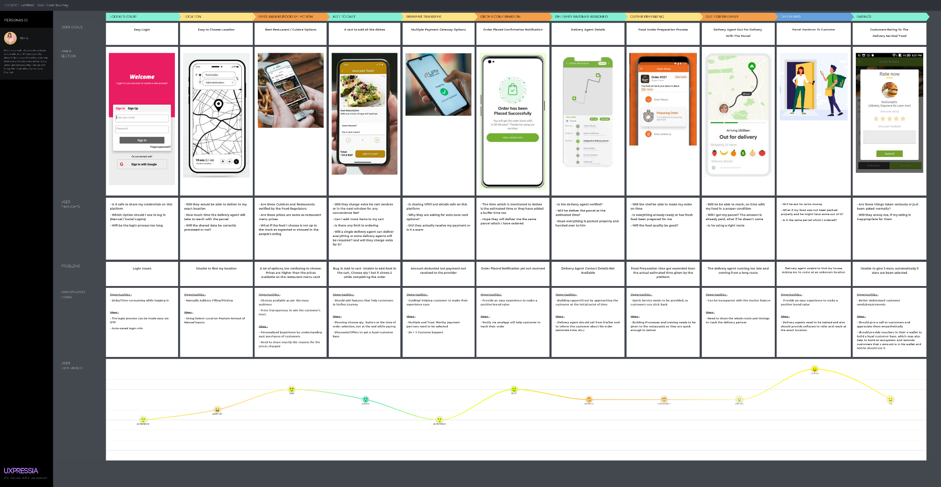

All content and material on the UpGrad website is copyrighted material, either belonging to UpGrad or its bonafide contributors and is purely for the dissemination of education. You are permitted to access print and download extracts from this site purely for your own education only and on the following basis: -

* You can download this document from the website for self use only.
* Any copies of this document, in part or full, saved to disc or to any other storage medium may only be used for subsequent, self viewing purposes or to print an individual extract or copy for non-commercial personal use only.
* Any further dissemination, distribution, reproduction, copying of the content of the document herein or the uploading thereof on other websites or use of content for any other commercial/unauthorized purposes in any way which could infringe the intellectual property rights of UpGrad or its contributors, is strictly prohibited.
* No graphics, images or photographs from any accompanying text in this document will be used separately for unauthorised purposes.
* No material in this document will be modified, adapted or altered in any way.
* No part of this document or UpGrad content may be reproduced or stored in any other web site or included in any public or private electronic retrieval system or service without UpGrad’s prior written permission.
* Any rights not expressly granted in these terms are reserved.